1) Install nginx and run nginx on port number 81.
configuration: /etc/nginx/nginx.conf
#yum install nginx –y
# systemctl restart nginx
# systemctl status nginx
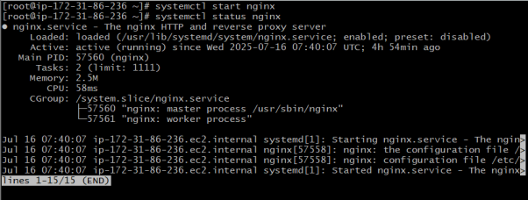
#cd /etc/nginx
# vi nginx.conf

2) Deploy a sample index.html file on nginx.
Deployment:usr/share/nignx/html
cd usr/share/nignx/html
vi idex.html
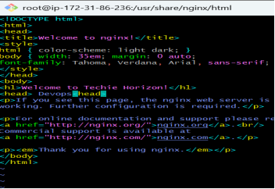
systemctl restart nginx
systemctl status nginx
Go to check the browser


3) Install Apache and run Apache on port number 82
Deployment:/etc/httpd/conf/httpd.conf
Yum install httpd
Systemctl start httpd
To check if it is running
Systemctl status httpd
Netstat –na | grep 80
Ps –ef | grep httpd

To change the port no:- 80 t0 82
cd /etc/httpd/conf
ls
ll
cat httpd.conf
vi httpd.conf
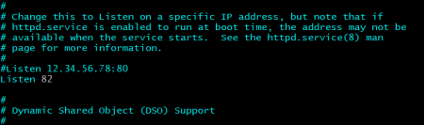
systemctl start httpd
systemctl status httpd
Go to browser to check.


4) Deploy a sample index.html file on Apache.
Deployment:/var/www/html
cd var/www/html
ll
vi index.html
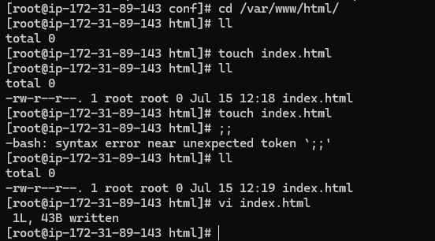
go to check the browser.
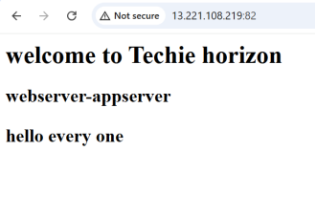
5) Install Apache tomcat on port number 8083.
Before installation of tomcat first we should have to install java (jdk)
yum install java
systemctl will not work for it to install tomcat use this
#wget
https://downloads.apache.org/tomcat/tomcat-11/v11.0.9/bin/apache-tomcat-11.0.9.tar.gz

for extraction
#tar -xvzf apache-tomcat-11.0.9.tar.gz
ls
#cd apache-tomcat-11.0.9/bin
#./startup.sh
Check if Tomcat is running:
#ps -ef | grep tomcat

To run tomcat in 8083 port
#cd /root/apache-tomcat-11.0.9
#cd conf
#ls
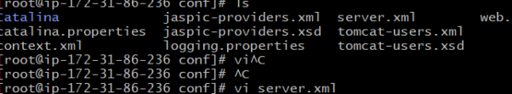
#vi server.xml
To change port no:-8080 to 8082

After updating the port no. we have to shutdown the tomcat and then restart for that we have
#./shutdown.sh
#./startup.sh

Go to the browser to check it is running.
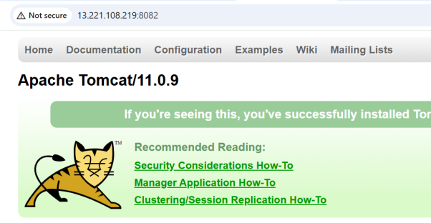

6) Deploy a sample app on webapps.

cd /root/apache-tomcat-11.0.9
ls
cd webapps
ls
ll

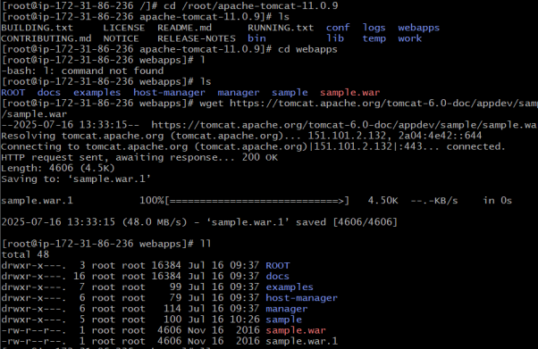

7) Create a tomcat.service file for tomcat.

#sudo nano /etc/systemd/system/tomcat.service

[Unit]
Description=Apache Tomcat 11
After=network.target

[Service]
Type=forking

User=ec2-user
Group=ec2-user

Environment="JAVA_HOME=/usr"
Environment="CATALINA_PID=/home/ec2-user/apache-tomcat-11.0.9/temp/tomcat.pid"
Environment="CATALINA_HOME=/home/ec2-user/apache-tomcat-11.0.9"
Environment="CATALINA_BASE=/home/ec2-user/apache-tomcat-11.0.9"

ExecStart=/home/ec2-user/apache-tomcat-11.0.9/bin/startup.sh
ExecStop=/home/ec2-user/apache-tomcat-11.0.9/bin/shutdown.sh

Restart=on-failure

[Install]
WantedBy=multi-user.target

# chmod +x /home/ec2-user/apache-tomcat-11.0.9/bin/*.sh

sudo systemctl daemon-reload
sudo systemctl enable tomcat
sudo systemctl start tomcat
sudo systemctl status tomcat

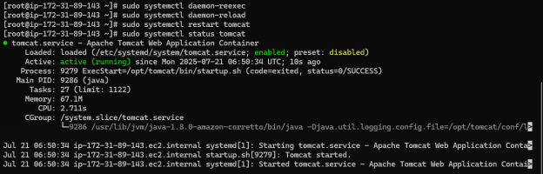

8) Configure HA Proxy server.

#sudo yum install haproxy –y
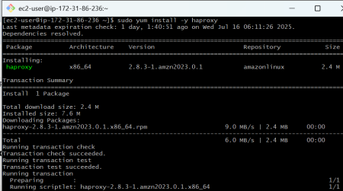

#sudo vi /etc/haproxy/haproxy.cfg
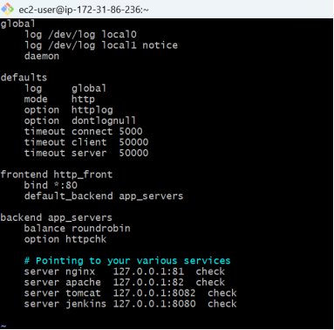
#haproxy –v
#sudo systemctl enable haproxy
#sudo systemctl start haproxy

#sudo systemctl status haproxy
